**DAILY ONLINE ACTIVITIES SUMMARY**

|  |  |  |  |  |  |  |  |  |
| --- | --- | --- | --- | --- | --- | --- | --- | --- |
| **Date:** | **19/06/2020** | | | | | **Name:** | **ASHISH GRACION MENEZES** | |
| **Sem & Sec** | **4&A** | | | | | **USN:** | **4AL18CS012** | |
| **Online Test Summary** | | | | | | | | |
| **Subject** | | **MICROCONTROLLER AND EMBEDDED SYSTEMS** | | | | | | |
| **Max. Marks** | | **20** | | **Score** | | | **20** | |
| **Certification Course Summary** | | | | | | | | |
| **Course** | **MICROSOFT AZURE ESSENTIALS** | | | | | | | |
| **Certificate Provider** | | | **Great Learning** | | **Duration** | | | **12 HOURS** |
| **Coding Challenges** | | | | | | | | |
| **Problem Statement1:Write a C program to count total set bits in all numbers from 1 to n** | | | | | | | | |
| **Status:Executed** | | | | | | | | |
| **Uploaded the report in Github** | | | | | **YES** | | | |
| **If yes Repository name** | | | | | **https://github.com/ash7745/lockdown-coding** | | | |
| **Uploaded the report in slack** | | | | | **YES** | | | |

Online Test Details1:18CS44(MES) test was conducted on 19/06/2020.There were 20 questions (mcq) with each question carrying 1 marks. The portion for the I.A was from 4th module

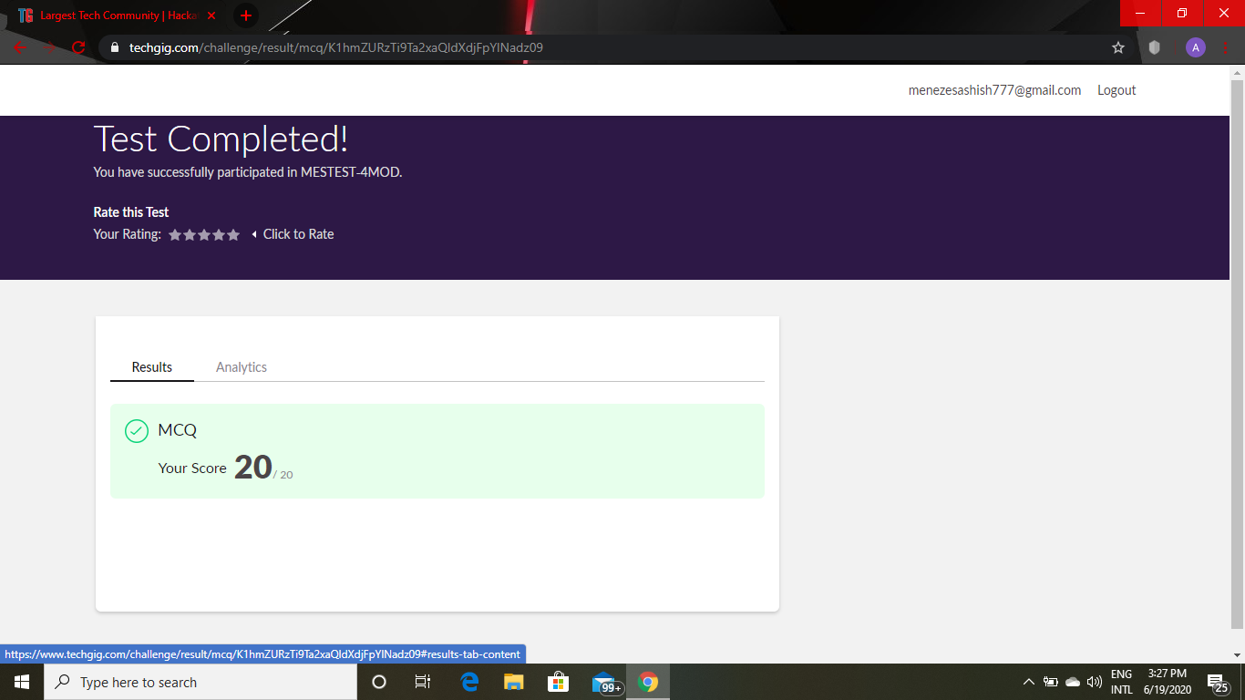

Certification Course Details: MICROSOFT AZURE ESSENTIALS(continuation)

.Today I have learnt 6 modules each of duration 30,14,15,16,27,19 minutes.Today I have downloaded study materials which I have to study which will be useful to do the project.

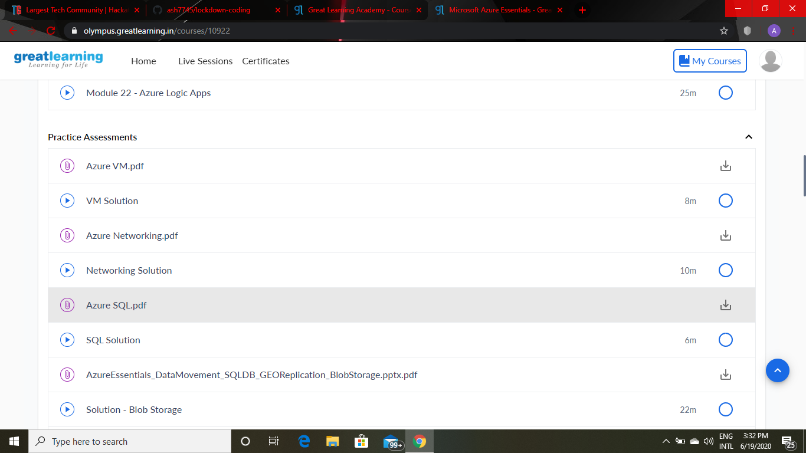

CODING DETAILS: Write a C program to count total set bits in all numbers from 1 to n

